PROJECT REPORT
ON
DATA VISUALISATION USING POWER BI


FACULTY OF COMPUTER APPLICATIONS:
SESSION 2025-2026

SUBMITTED BY:
Vaishnavi Choudhary
BCA (AI & ML) in collaboration with IBM
UU ID: 252010228
SUPERVISED BY:
Mr. Farhan

UNITED UNIVERSITY
RAWATPUR, PRAYAGRAJ, UTTAR PRADESH-211002

INTRODUCTION

Data Visualization is the process of representing data in visual forms such as charts, graphs, maps, and dashboards to make information easy to understand and analyse. In Business Intelligence (BI), data visualization helps organizations convert raw data into meaningful insights for better decision-making.
The dataset used in this project contains water quality information collected from different cities and water sources. It was obtained from Kaggle and includes various physical, chemical, and biological parameters that help evaluate the safety and quality of water. The dataset provides valuable insights into environmental conditions and public health risks associated with water contamination.
The data includes important attributes such as pH level, turbidity, dissolved oxygen, bacteria count, heavy metals, total dissolved solids (TDS), disease risk, population affected, and water quality status. These parameters are widely used to assess whether water is safe for human consumption and aquatic life.
By analyzing this dataset, it becomes possible to identify polluted regions, detect contamination patterns, compare water quality across different locations, and understand the factors affecting water safety. The dataset serves as the foundation for creating interactive Power BI dashboards that transform raw data into meaningful visual insights for decision-making and environmental monitoring.

OBJECTIVES OF THE PROJECT

The main objective of this project is to analyse and visualize water quality data using a BI dashboard to understand the safety and health impact of water across different regions.
- To evaluate water safety across different geographical locations using key indicators such as pH, turbidity, dissolved oxygen, and bacteria count.
- To perform Exploratory Data Analysis (EDA) and identify relationships, especially the correlation between turbidity and bacteria count, which helps understand water contamination patterns.
- To identify high-risk areas where the disease risk is marked as “Critical”, highlighting regions that need urgent attention.
- To analyze the impact of heavy metals on overall water quality, helping detect polluted and unsafe water sources.
- To study and visualize seasonal variations in water quality parameters, showing how environmental changes affect water conditions over time.

These objectives help in converting raw water quality data into meaningful insights through visual analytics, supporting better decision-making for environmental safety and public health.

TOOLS AND TECHNOLOGIES USED

- Python: Used for data analysis, manipulation, and performing basic statistical operations. It helped in understanding and exploring the dataset.

- Pandas: A Python library used for data cleaning, handling missing values, and organizing data in structured Data Frames for analysis.

- Microsoft Power BI: Used to create interactive dashboards, visualizations, KPIs, maps, and charts to represent water quality insights effectively and support decision-making.

- Excel: Used for initial data viewing, inspection, and storing datasets in tabular format before importing into analysis tools.

- Kaggle: Used as the data source platform to obtain real-world datasets for water quality analysis and visualization.

DATASET DESCRIPTION
The dataset used in this project is a water quality dataset obtained from Kaggle and is used to analyse the safety and health conditions of water across different geographical locations.The cleaned dataset now contains the most relevant attributes required for analysis and visualization in Power BI.
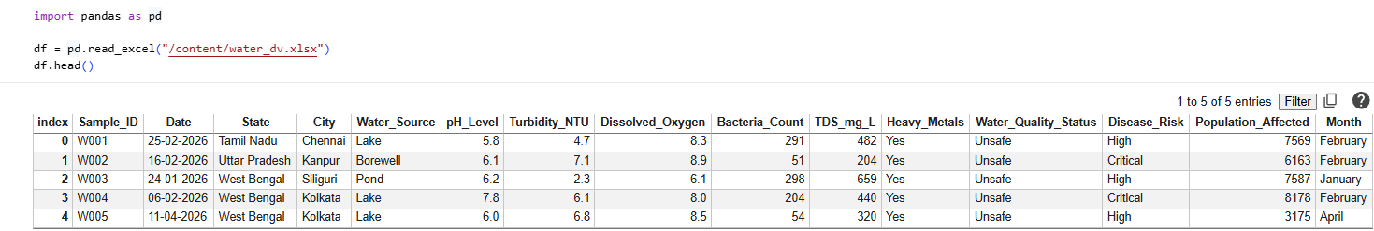
The above dataset shows first few rows of dataset, providing an overview of data
Main Features of Dataset
- City / State: Represents geographical location of water samples
- Water Type: Indicates source such as river, lake, groundwater, etc.
- pH Level: Measures acidity or alkalinity of water
- Turbidity: Shows clarity or cloudiness of water
- Dissolved Oxygen: Indicates oxygen level in water
- Bacteria Count: Measures microbial contamination
- Heavy Metals: Shows presence of harmful metals
- TDS (Total Dissolved Solids): Measures dissolved substances in water
- Water Quality Status: Classified as Safe or Unsafe
- Disease Risk: Indicates health risk level (Low / Moderate / Critical)
- Population: Represents number of people affected
- Year: Used for time-based analysis
EXPLORATORY DATA ANALYSIS

Exploratory Data Analysis (EDA) was performed on the water quality dataset to understand its structure, detect patterns, and extract meaningful insights before building the Power BI dashboard. The dataset includes key variables such as pH level, turbidity, dissolved oxygen, bacteria count, heavy metals, water quality status, disease risk, city, and population. After importing the dataset, the first few rows were viewed to understand the data format, and unnecessary columns.
During EDA, it was observed that water quality varies significantly across different cities. Some regions show higher levels of contamination, especially in terms of bacteria count and turbidity. A relationship was identified between turbidity and bacteria count, where higher turbidity generally indicates increased bacterial contamination. The pH level distribution helped classify water as safe or unsafe, while heavy metal presence was found to have a negative impact on overall water quality status. Disease risk analysis further highlighted that certain cities fall under the “Critical” category due to poor water conditions.
Overall, EDA helped in identifying important trends, correlations, and high-risk areas in the dataset, which were later visualized using Microsoft Power BI dashboards for better understanding and decision-making

IMPORTING LIBRARIES , CLEANING DATA AND DATA OVERVEIW
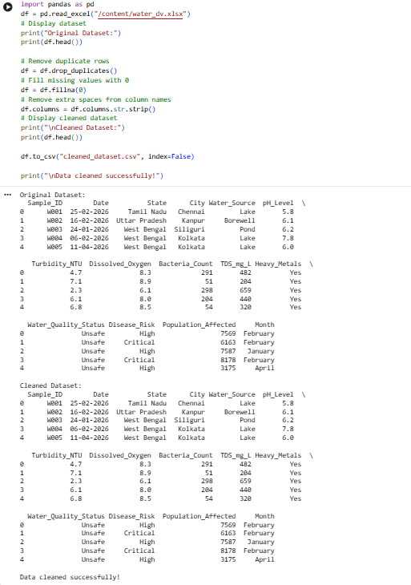

Python libraries such as Pandas were imported to perform data loading, cleaning, and analysis. The dataset was cleaned by removing duplicates, handling missing values, and dropping unnecessary columns to improve accuracy. Finally, the dataset was explored using functions like head() to display the first few records and understand the structure, features, and overall overview of the data before visualization and dashboard creation.
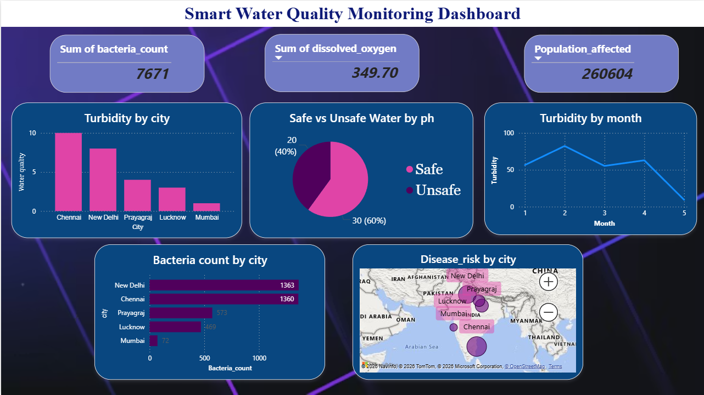
INSIGHTS AND VISUALISATION
Insight 1: KPI cards
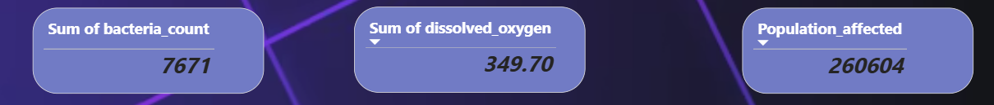
FIG 1 FIG 2 FIG 3

The KPI cards in the dashboard provide a quick summary of the overall water quality condition and its environmental impact.
Fig 1: The Sum of Bacteria Count (7671) represents the total microbial contamination present in all water samples. A higher bacteria count indicates poor water quality and increases the risk of waterborne diseases such as cholera, typhoid, and diarrhoea. This shows that several water sources in the dataset are affected by biological contamination and require proper treatment.
Fig 2: The Sum of Dissolved Oxygen (349.70) indicates the overall oxygen availability in the water bodies. Dissolved oxygen is an important indicator of water health because aquatic life depends on it for survival. Higher values generally represent better water quality, while lower values may indicate pollution or organic waste presence. In this dataset, variation in dissolved oxygen reflects differences in water conditions across regions.
Fig 3: The Population Affected (260,604) represents the total number of people living in areas where water samples were collected. This KPI highlights the scale of impact of water quality issues on human life. A higher affected population means that a large number of people are exposed to unsafe or potentially contaminated water, increasing public health concerns

INSIGHT 2: BAR CHART

Turbidity by City (Bar Chart)
Chennai has the highest turbidity level, indicating the water is more polluted or contains more suspended particles.
New Delhi also shows high turbidity, making it another high-risk area.
Mumbai has the lowest turbidity, suggesting comparatively cleaner water.
High turbidity can reduce water quality and increase the possibility of water-borne diseases.

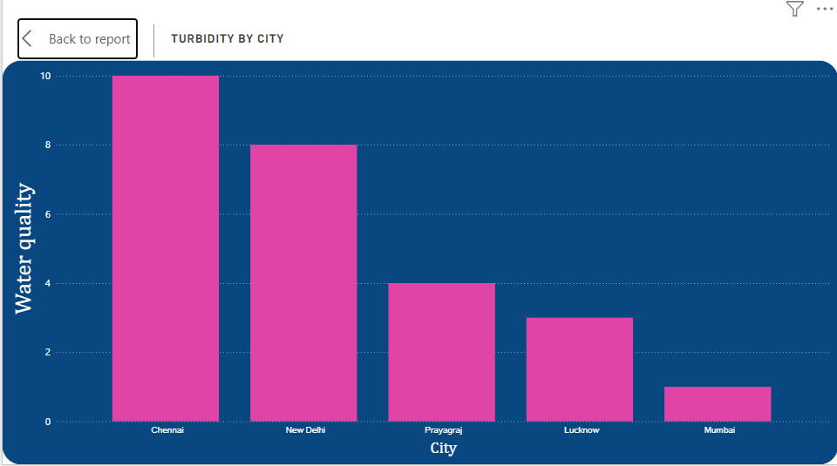

INSIGHT 3: PIE CHART

Safe vs Unsafe Water by pH (Pie Chart)
This shows that around 60% of the water samples are safe, while 40% are unsafe based on pH levels. This indicates that a considerable portion of water sources does not fall within the ideal drinking water range. Extreme pH levels can make water either too acidic or too alkaline, which may affect human health and aquatic ecosystems.

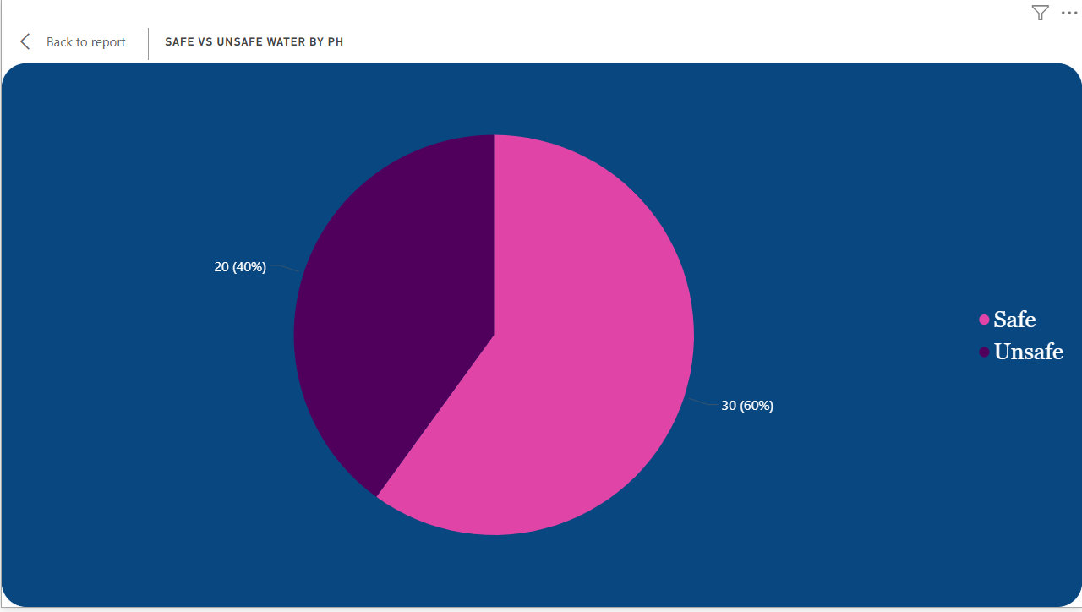

INSIGHT 4: LINE CHART

Turbidity by Month (Line Chart)
In the fluctuations in water quality are clearly visible over time. Turbidity increases during certain months, likely due to seasonal changes such as rainfall and runoff carrying pollutants into water bodies. After reaching a peak, turbidity gradually decreases, with a noticeable improvement in later months, showing possible natural settling of particles or effective water treatment measures.

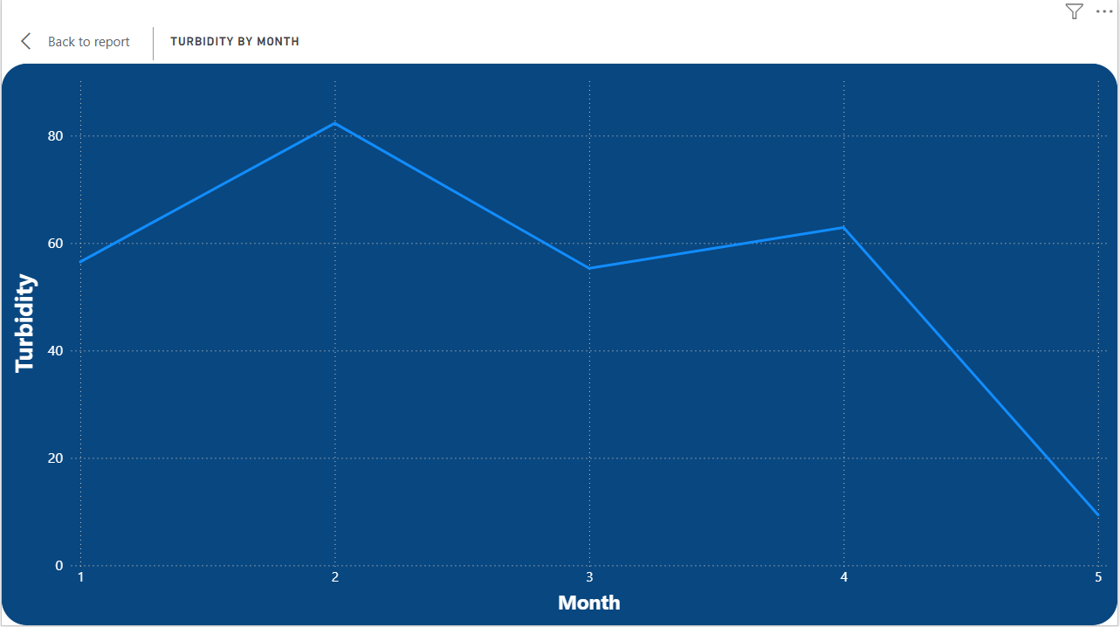

INSIGHT 5: STACKED BARCHART
Bacteria Count by City
The highlights that New Delhi has the highest bacterial contamination, followed by Chennai. High bacteria levels indicate poor sanitation and contamination of water sources, which significantly increases the risk of diseases like cholera, typhoid, and diarrhoea. Mumbai shows the lowest bacterial count, indicating better water hygiene and treatment practices. Bacterial contamination is closely linked with water pollution and is a major factor affecting water safety.

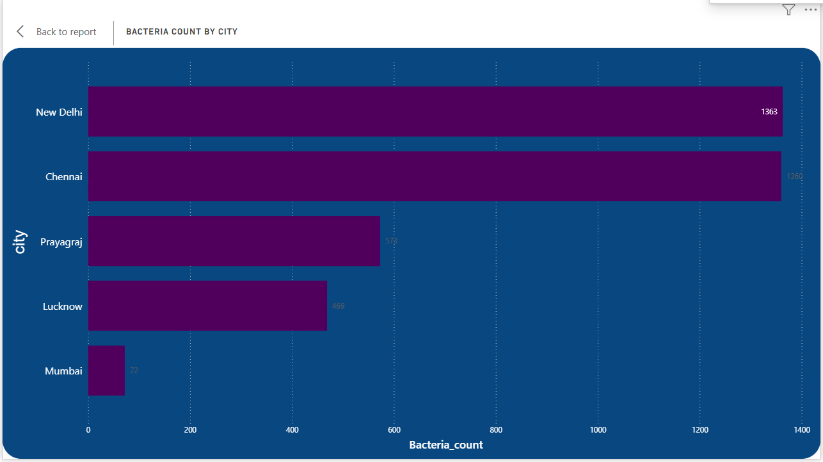

INSIGHT 6: MAP
Disease Risk Map Visualization
The shows that cities with high turbidity and bacteria levels, such as Chennai and New Delhi, fall under the critical risk category. These areas are more likely to experience waterborne disease outbreaks due to poor water quality conditions. The geographic visualization helps in identifying high-risk zones for immediate attention and intervention.

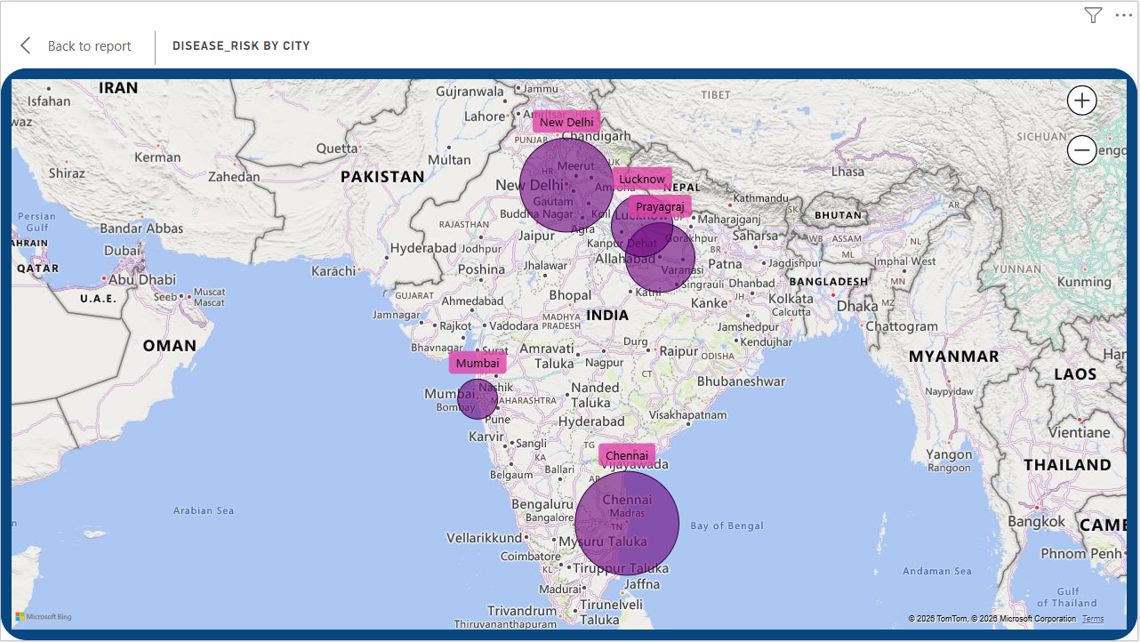
CONCLUSION
The Smart Water Quality Monitoring Dashboard successfully analyses and visualizes water quality data to understand the safety and health conditions of water across different cities. By using key parameters such as pH level, turbidity, dissolved oxygen, bacteria count, heavy metals, and disease risk, the project provides clear insights into water pollution patterns and their impact on human health.
The analysis shows that water quality varies significantly across geographical locations, with cities like Chennai and New Delhi experiencing higher turbidity and bacterial contamination levels, indicating poor water conditions. These areas are identified as high-risk zones where the possibility of waterborne diseases is greater. The relationship between turbidity and bacteria count also highlights that polluted and unclear water tends to have higher microbial contamination, making it unsafe for consumption. Similarly, heavy metals and extreme pH levels contribute to unsafe water classification and increased health risks.
Overall, this project demonstrates how data visualization and Business Intelligence tools like Microsoft Power BI can effectively transform raw environmental data into meaningful insights. It helps in identifying critical regions, understanding pollution trends, and supporting better decision-making for water quality management and public health improvement

REFRENCES
- Kaggle Dataset
Dataset used for water quality analysis was obtained from Kaggle, a platform that provides real-world datasets for data science projects.
https://www.kaggle.com/
- Python
Python was used for data analysis and processing in this project. It is a powerful programming language for data science and visualization.
https://www.python.org/doc/
- Pandas Library
Pandas is a Python library used for data cleaning, manipulation, and analysis of structured datasets.
https://pandas.pydata.org/docs/
- Microsoft Power BI
Power BI is a Business Intelligence tool used to create interactive dashboards, charts, and reports for data visualization.
https://powerbi.microsoft.com/
- Microsoft Excel
Excel was used for initial data viewing and basic data handling before analysis and visualization.
https://www.microsoft.com/en/microsoft-365/excel

FUTURE SCOPE

The Smart Water Quality Monitoring Dashboard can be further enhanced by integrating advanced technologies and real-time monitoring systems. Future improvements may include the use of IoT (Internet of Things) sensors to collect live water quality data from different locations, enabling continuous monitoring and instant updates. Machine Learning algorithms can be incorporated to predict future water quality conditions and identify potential contamination risks before they become critical.
The dashboard can also be expanded to include additional environmental parameters such as temperature, rainfall, and industrial waste discharge to provide more comprehensive analysis. Mobile and web-based applications can be developed to allow government agencies and citizens to access water quality information easily. Furthermore, automated alert systems can be implemented to notify authorities when water quality reaches unsafe levels, helping ensure timely intervention and public safety.

